Portishead Youth Centre Quiz

Round 1: General knowledge
1.How long is the Great Wall of China? 4,000 miles
2.What is the name of the sugar found in milk? Lactose
3.What colour star is on the Vietnam flag? Yellow
4.How many candles does the The Hanukkah menorah have? Nine
5.How is 77 represented in Roman numerals? LXXVII
6.Which is the largest land carnivore in Britain? Badger
7.How many stomachs does a cow have? Four
8.How many strings does a Harp have? 47
9.Brights’ disease affects which organs of the body? Kidneys
10.Which language did the Romans speak? Latin

Round 2: Film and Fiction
1.What is the name of the fourth book in the ‘Harry Potter’ series? Harry Potter and the Goblet of Fire
2.In the strip cartoon, what is the name of Snoopy’s brother? Spike
3.Which Johnny starred as Edward Scissorhands?
Jonny Depp
4.In which Fictional land is Game of Thrones set? Westeros
5.In the Simpsons, what is Bart’s second name? Jo-Jo
6.What is the name of the little dragon in the animated movie Mulan? Mushu
7.Who does Princess Fiona fall in love with? Shrek
8.What is the name of the Lion in The Lion, The Witch and the Wardrobe? Aslan
9.In the children's book the BFG, what do the initials BFG stand for? Big Friendly Giant
10.Who pricked her finger on a spinning wheel and slept for 100 years? Sleeping Beauty

Round 3: Famous faces
1.Name all the members of the Jackson 5
Jackie, Tito, Jermaine, Marlon and Michael
2.Which country does Bryan Adams come from?
Canada
3.What is American Buzz Aldrin famous for?
Being the second man to walk on the moon
4.Who was the winner of the first ever UK series of ‘I’m A Celebrity… Get Me Out of Here!’? Tony Blackburn
5.In 2019 who became the first woman to win an Oscar, Grammy BAFTA and Golden Globe in the same year? Lady GaGa
6.What was the name of AC / DC s lead singer who died in 1980? Bon Scott
7.Name two of Angelina Jolie’s three husbands.
Brad Pitt, Billy Bob Thornton and Jonny Lee Miller (Any two of)
8.Who presented the 2015 series of “Big Brother” in the UK? Emma Wills
9.What is the singer Adele’s surname?Adkins
10.Who played the role of Peter Pan in the Live action Peter Pan movie? Robin Williams

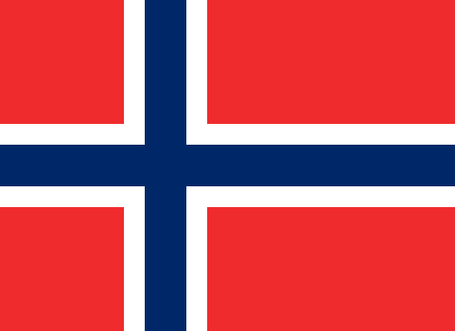
Round 4: Flags of the world
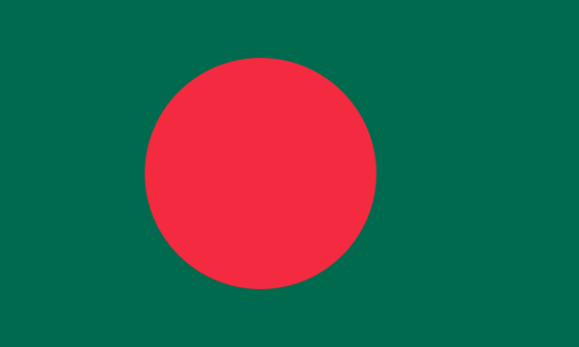

Bangladesh
Norway
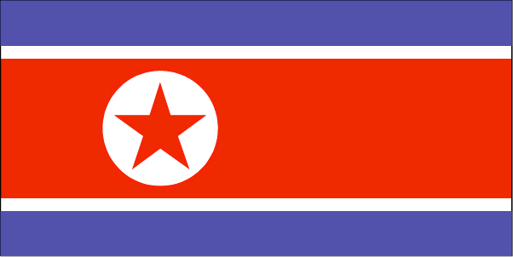
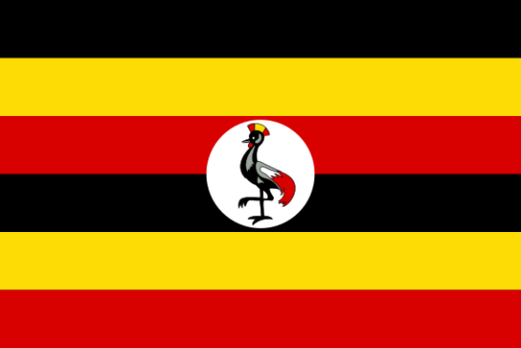

North Korea
Uganda
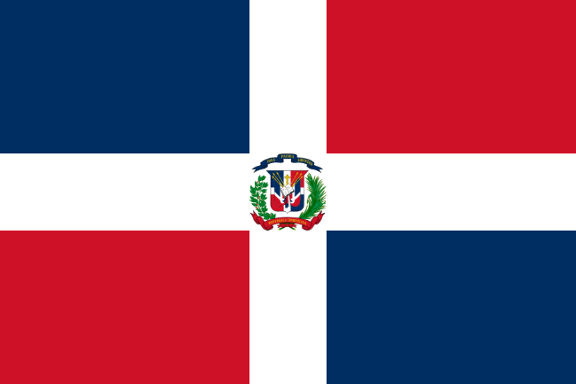
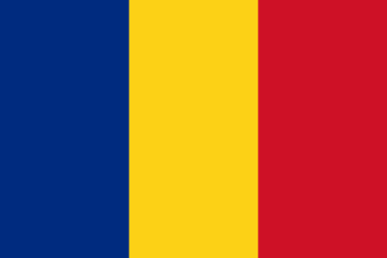

Dominican Republic
Romania


Round 5: Logo round


PIZZA HUT
Taco Bell



Marvel Comics
Nickelodeon



Safari
Rolex




Victoria’s Secret
The North Face



Best Buys
Walmart



Cabbage Patch Kids
Converse


Nintendo
Beats by Dre



Fanta
Spotify
Round six: Disney Round
- In the Lion King, where does Mufasa and his family live?
Pride rock/Pride land (either accepted)
- In Mary Poppins, what animal was on the end of Mary Poppins’ umbrella that spoke?
A parrot
- Who was the first Disney princess?
Snow White

- In Aladdin, what is the name of Jasmine’s pet tiger?
Rajah
- When does Mary Poppins say she will leave the Banks’ house?
When the wind changes
- What are the names of Cinderella's evil stepsisters?
Anastasia and Drizella (1 point for each)

- Which Disney film is set on a Hawaiian Island?
Lilo and Stitch
- 'Two Worlds' is a song from which Disney film?
Tarzan

- Which Disney character sings the song 'Be Prepared'?
Scar- Lion King (Bonus point)
10.What does Woody from Toy Story have in his boot?
A snake


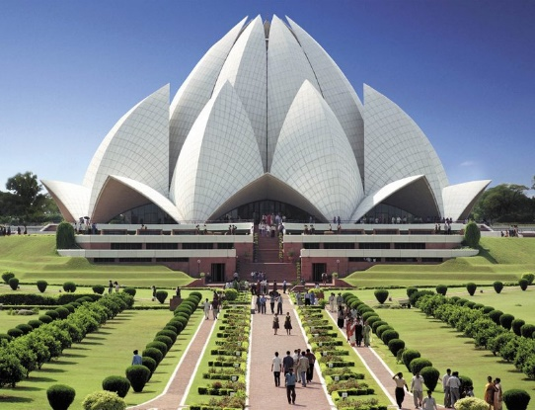
Round 7: Historic Landmarks

New Delhi, India
Toronto, Canada
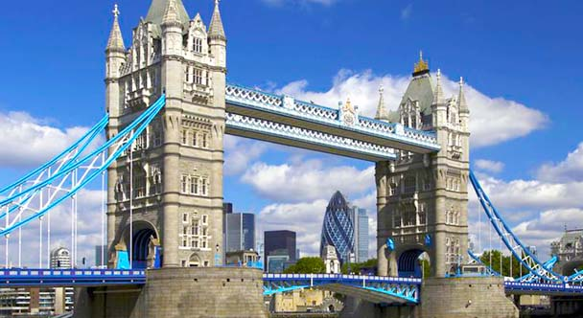
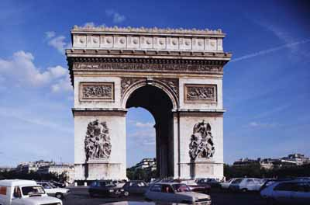

Paris, France
London, England
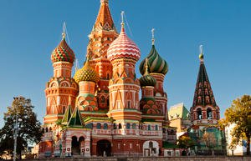
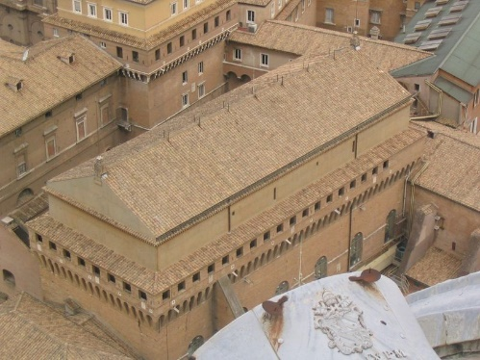

Rome, Italy
Moscow, Russia

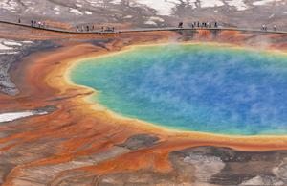
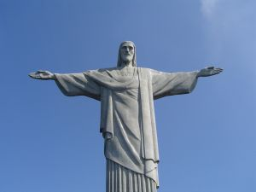

Yellowstone, National Park, USA
Rio de Janeiro, Brazil
Round 8: Sports
1.In which country does the sport, Sumo wrestling originate from? Japan
2. How long is an Olympic swimming pool? 50 metres (164ft)
3.In Cricket scoring, what does C & B stand for?
Caught and bowled
4. How many minutes are there in a Rugby match?
80 minutes
5. What is the largest stadium in the world?
Azteca Stadium in Mexico city (Bonus point for place)
6. What was the Olympic city of 1992 ? Barcelona
7.What ball is worth the most points in English Pool
The eight ball/Black ball
8.Who was the champion of the Tour de France from 1999 to 2005? Lance Armstrong
9.How long is there between rounds in boxing? 1 Minute
10.Which popular fitness method was invented in Germany Pilates

Round 9: Food and Drink
1.What is the most famous beer in Ireland?
Guiness
2.From which country does pitta bread originate?
Greece
3.From which type of flower does a vanilla pod come? Orchid
4.If you saw ‘chou-fleur’ on a French menu which vegetable would the dish include? Cauliflower
5.What two fruits grow on palm trees?
Coconuts and dates (1 point for each)
6.Which beverage has been marketed with the slogan ‘Great Taste, Zero Sugar’? Coke Zero
7.What type of wine is ‘Sekt’?
White Wine (German Sparkling White Wine-Bonus)
8.Carrots are especially rich in which vitamin?
A
What is Laver Bread made from? Seaweed
10.What Type of Food Is Pepperoni?
Spiced sausage
Round 10: BONUS MUSIC ROUND
- This is me- The Greatest Showman
- I just can’t wait to be king- The Lion King
- Angels- Robbie Williams
- 2002- Annemarie
- Colours- Jason Derulo
- Cannonball- Little Mix
- 5678- Steps
- Hello my love- Westlife
- Spoonful of Sugar- Mary Poppins
10.9 to 5- Dolly Parton

